



Self-employment and benefits


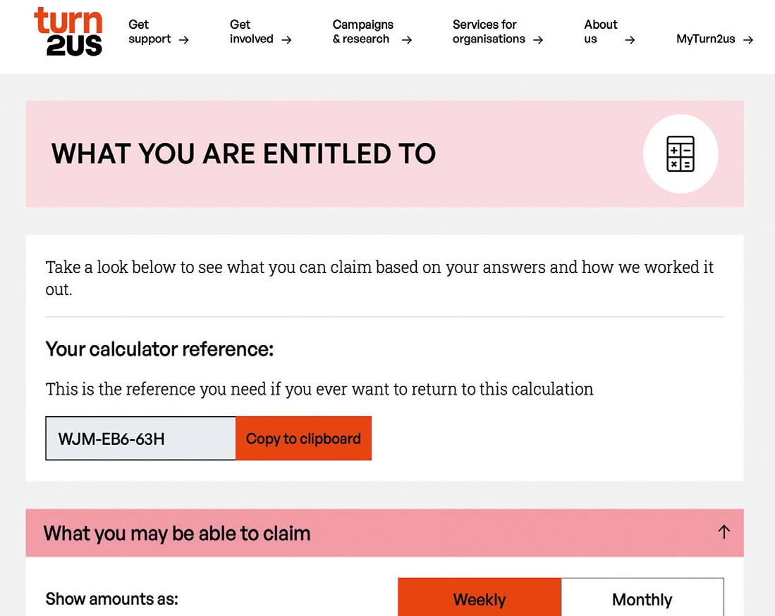
Step one: Go through the Benefits Calculator with your current situation.
Step two: On the results screen, click ‘See what you would get if you started/changed work’.

Here you can put in your planned hours and earnings and see how that will affect your
benefits entitlement.

Your earnings will usually affect how much benefits you can get. This depends on what benefits you’re receiving already.
The easiest way to check how your benefits are affected by earnings is to use the free Turn2us Benefits Calculator.


.
benefits-calculator.turn2us.org.uk

Turn2us is a national charity offering information and practical help to people facing financial insecurity.
Figures current as of April 2026 - March 2027.

Some tips

Employment and Support Allowance
If you get income-related Employment and Support Allowance, you can earn up to £203.50 per week without it affecting your benefits
– but you will need to complete a permitted work form. You can get the form at the local job centre. If you’re self-employed, your weekly earnings can be averaged over a longer period depending on your circumstances.

Fluctuating earnings
If you earn more in some weeks and less in other weeks, this will mean your means-tested benefits entitlement will keep changing.
Make sure you tell your work coach or job centre adviser about your earnings regularly. If you receive Universal Credit, Housing Benefit, or Council Tax Support, you must let them know if your income changes.

Universal Credit and self-employment
Universal Credit (UC) is based on your income, including earnings through Pay as You Earn (PAYE) and/or self-employment, and it does not matter how many hours you work.
If you’re self-employed, you are treated as if you are earning a certain amount (usually what someone of your age would earn if they worked at the National Minimum Wage for the number of hours that are expected to work or look for work). This amount is called the ‘minimum income floor’. If you earn below this level in any month, you are treated as earning the minimum income floor. If you are earning more than the minimum income floor, your actual earnings are taken into account instead.
You will be exempt from the minimum income floor for 12 months if:
- You were self-employed when you claimed UC
- OR you become self-employed after starting your UC claim
- OR the type of your self-employed business’s main activity changes
Carer’s Allowance
Carer’s Allowance stops if you earn more than £204 per week.
Carer’s Element of Universal Credit doesn’t have any rules about your earnings. If you’re self-employed, your weekly earnings can be averaged over a longer period depending on your circumstances.

Personal Independence Payment (PIP)
You can claim PIP and still work. Your claim will not be affected by your work or earnings.
It’s useful to keep track of any accommodations that are made for your disability so you can explain it to the Department of Work and Pensions if they need that information.

