Trustee Recruitment Pack

June 2026

RTYDS is seeking four people to join our Board of Trustees. We are looking for perspectives, experience and skills from a range of people, to support this significant next phase of the company’s development.

Deadline for applications: 12 noon, Monday 20 July 2026

The pack is also available in audio, large print, and as a screen reader accessible version, and they can be found at www.rtyds.co.uk/jobs.

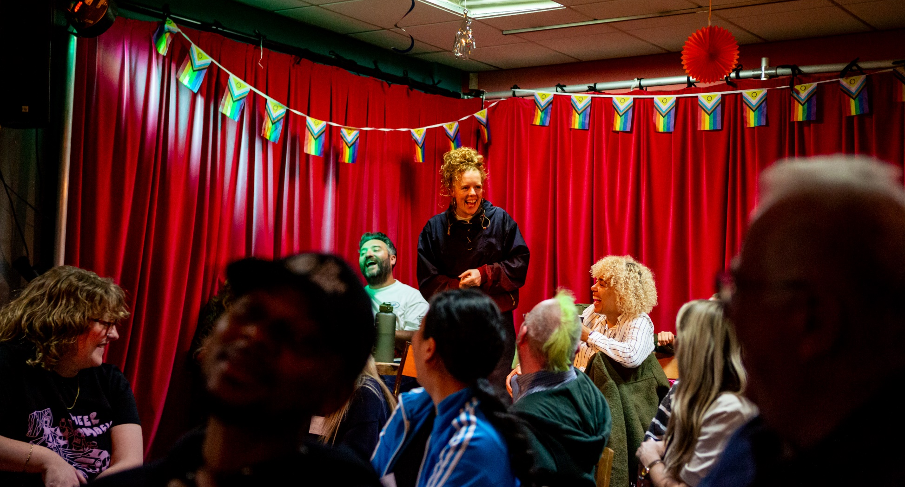
Photo by Tom Woollard

Thank you for your interest in joining our Board of Trustees.
It’s an exciting time for us as we deliver our major new Arts Council Funded project called Fair Play which, in partnership with theatres and artists, aims to tackle class inequity in the theatre industry. We are also planning to apply to Arts Council England later in the year with the ambition that we will return to regular funding as an NPO.
We are looking for four committed Trustees who will join us to deepen our strategy over the coming months. We’re committed to addressing the barriers experienced by working class and low socio-economic artists to ensure they can sustain careers and thrive in the theatre industry and hope you will help us achieve this.
The Board has recently undertaken a skills audit of current and departing members. We have some specific needs outlined below. We would welcome strategic thinkers, creative communicators, and those with an unwavering commitment to equality, diversity, and inclusion.
An understanding of the current issues facing the arts and theatre sector in particular is welcome but not a requirement. Perspectives and skill sets from different industries can be a great addition to our Board.
We are particularly keen to meet people who continue to be under-represented in our workforce and in the wider theatre industry. Working-class voices lead, shape, and define our work and we want this also to be reflected in the make-up of our Board. This includes people who are: Black or Global Majority; Deaf and or disabled, neurodivergent and LGBTQIA+.
Given our regional focus, we specifically would like to hear from people who are living and working outside of London.
We hope you find everything you need in the pack about the company and the role but you are also very welcome to get in touch for an informal and confidential conversation with our Chair Christina Clarke at christinaclarke@rtyds.co.uk or Artistic Director Sue Emmas on sueemmas@rtyds.co.uk
We are committed to providing the knowledge, skills and support you need to take on this role. You don’t need to have been a Trustee before. A comprehensive onboarding process will be provided, alongside any required additional training, upon request.
We want you to have the opportunity to tell us about yourself and your interest in RTYDS Fair Play in whatever way feels most appropriate and we accept proposals in writing, video or audio format.
We look forward to hearing from you.
Christina Clarke
Chair on behalf of the Board of Directors
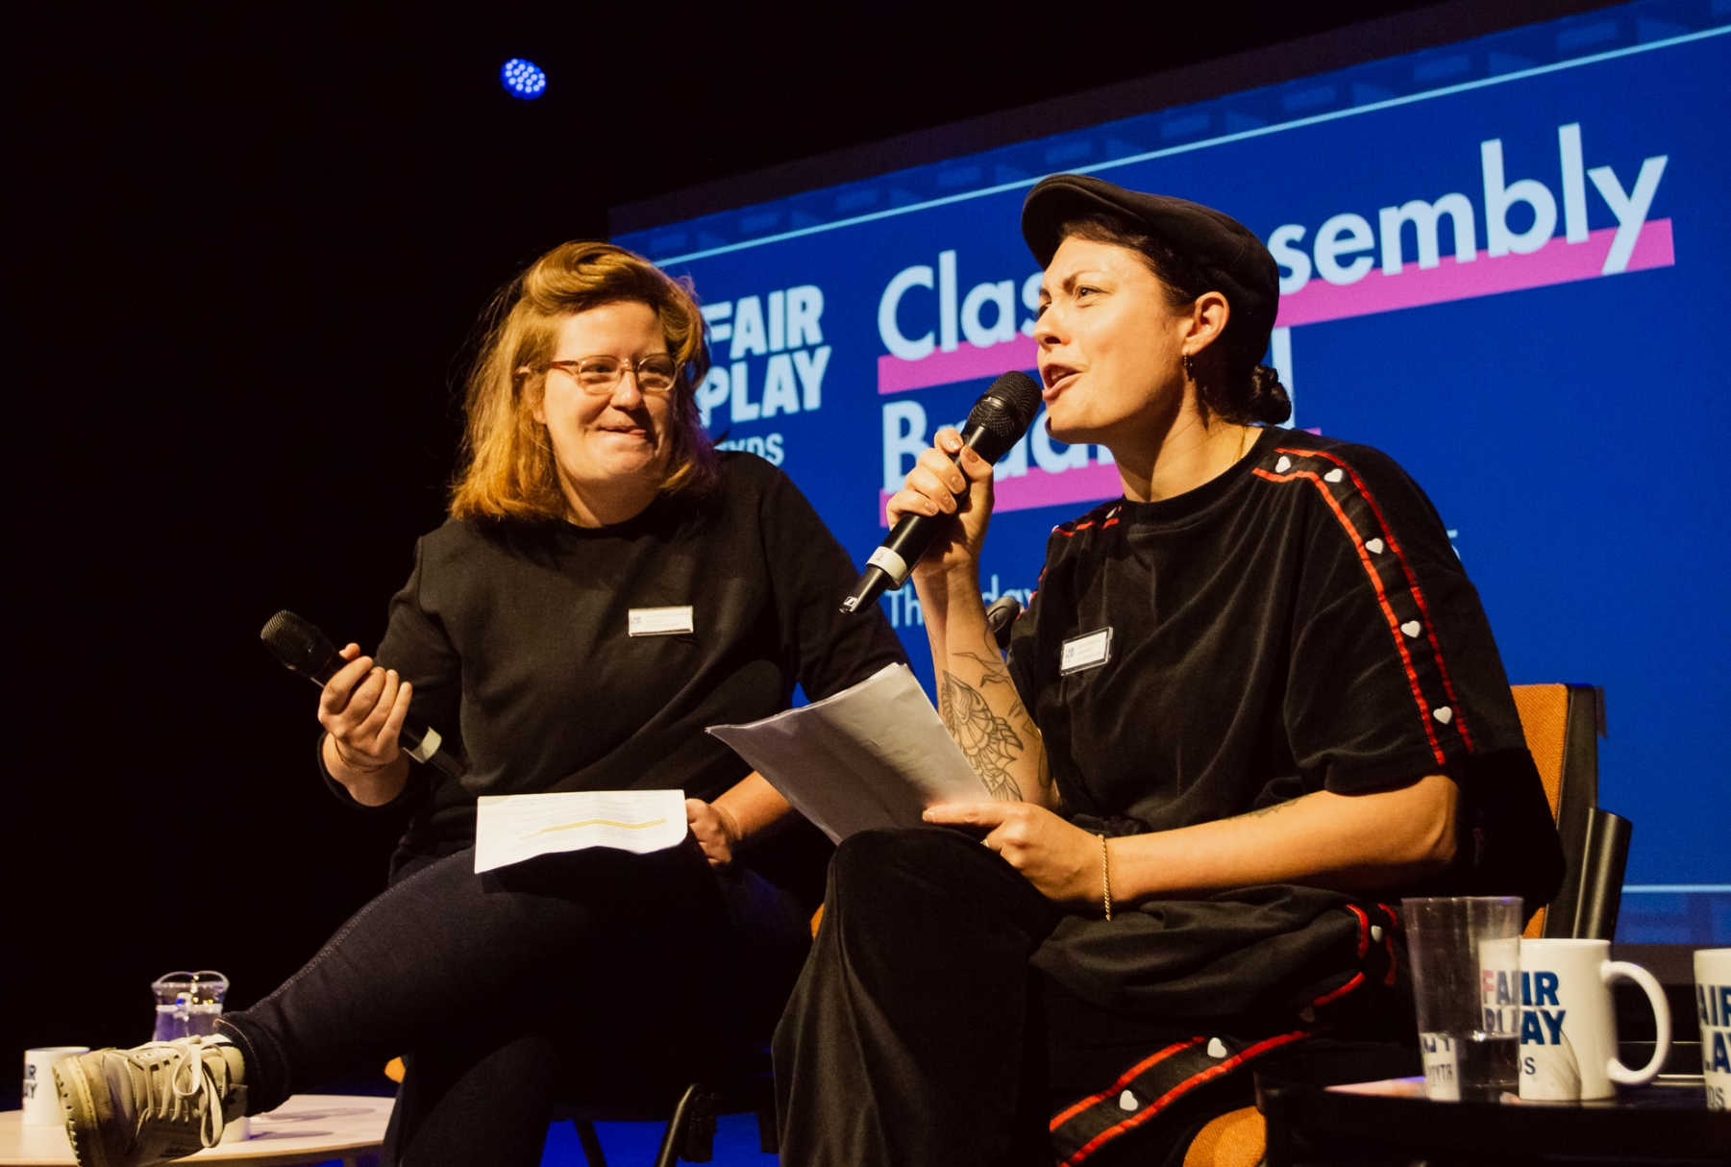
Photo by Tom Woollard

CONTENTS

RTYDS - FAIR PLAY 6
THE TEAM 11
THE BOARD 13
THIS OPPORTUNITY 15
HOW TO APPLY 20

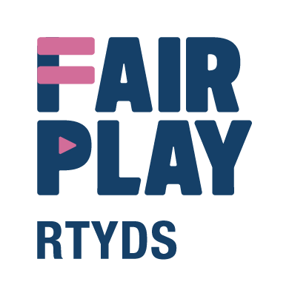

RTYDS - FAIR PLAY
The Regional Theatre Young Director Scheme was started in 1960 by ABC Television to help further the careers of aspiring theatre producers and directors. Its founders believed that television owed a debt of gratitude to the theatre for its supply of creative talent.
Jack Andrews MBE administered the project for 20 years and over this time ensured that it continued to grow from strength to strength. In 2007 he retired and invited the Young Vic to take over his managerial responsibilities for the scheme.
RTYDS was radically reimagined in 2015 with Arts Council England and sector-wide support to challenge and dismantle barriers in artistic leadership arising from inequality of opportunity. We partnered with organisations across England to provide professional development opportunities for new, early career and experienced theatre directors.
RTYDS alumni are leading theatres around the country, with recent appointees including Taio Lawson at The Bush Theatre, Jesse Jones at Royal and Derngate in Northampton, Elizabeth Newman at Sheffield Theatres, Jack McNamara at Live Theatre in Newcastle, Natalie Ibu at Northern Stage in Newcastle, and Corey Campbell at The Belgrade Theatre in Coventry. Freelance directors who have also participated in RTYDS schemes include John Tiffany, Vicky Featherstone and Rebecca Frecknall.
We are proud to have led on change in leadership diversity in theatre, working with theatre partners across the country for the last 15 years. In 2023 the overwhelming evidence around class-based discrimination compelled us to place all our efforts and tried and tested practices to challenge the systemic barriers that prevent theatre makers from working class or low socio-economic backgrounds from sustaining creative careers and fulfilling their potential as artists and cultural leaders.
The crisis of class representation in the arts is well established - but isn’t being tackled. Our vision is an industry where socio-economic background doesn’t dictate an artist’s artform, destination or career duration. Where working class leaders can thrive and where our theatre sector is robust, socially just, and able to recognise, develop and nurture working class talent.
Our mission is to bring together theatres, theatre companies, trade unions, and third sector experts alongside mid-career artists across England to identify the cultural and systemic barriers that prevent artists from working class backgrounds from sustaining careers and progressing to leadership.
At the heart of Fair Play is lived experience and a driving force behind the ambitions of the initiative are our two Co-Creative Leads, Caitriona Shoobridge and Stef O’Driscoll, who are working alongside Artistic Director, Sue Emmas, in designing and delivering the programme.
In Fair Play we work in partnership with a network of theatres, theatre companies, unions and trade bodies and third sector experts across England to highlight and address financial, cultural and social structural barriers in practical, demonstrable and replicable ways. We do this through a scalable programme of education for the sector to increase financial and benefit literacy, opportunities for working class artists at senior management levels, leadership pathways and network building, mentoring, campaigning and advocacy.

We are currently working with partner organisations such as Liverpool Everyman & Playhouse, Bristol Old Vic, Leeds Playhouse, 20 Stories High, Bradford City of Culture 2025, Bradford Producing Hub, Cardboard Citizens, Stephen Joseph Theatre, and Turn2us.

In the summer of 2025, we launched our first wave of Fair Play programmes, including:

Associate Artistic Director Residencies: RTYDS is partnering with Bristol Old Vic, Leeds Playhouse and Liverpool Everyman and Playhouse to each host a mid-career director who is working class or from a low socio-economic background, in residence for 18 months. The Associate Artistic Director will develop their craft and understanding of creative leadership in a live theatre environment.
Leadership Pathway Bursaries: A pilot programme which aims to address the significant lack of diversity in those who lead organisations. It provides a progression route for talented people who hope to be artistic or creative directors. Each participant receives a fee to cover their time and has access to support, training, workshops and mentoring, working alongside RTYDS’s current cohort of theatre professionals from similar backgrounds who are already on a pathway to leadership.
Surviving on a Shoestring: A 12-month finance equity programme which pilots new ways of paying creative freelancers who are in receipt of benefits or are experiencing long-term financial instability. The scheme has partnered with 13 theatres so far. Participating organisations have included: Cardboard Citizens, Middle Child, Unfolding Theatre, Northern Broadsides, Mikron, Streetwise Opera, and Stephen Joseph Theatre.
Class Assembly: Events which bring together theatres, companies and artists to understand the deep-rooted socio-economic inequity in the arts and take away tangible action points to make change. We have led two events so far; one in Liverpool with 20 Stories High and Liverpool Everyman & Playhouse, and one in Bradford in partnership with Bradford 2025 UK City of Culture, Bradford Producing Hub and Common/Wealth. We hope to hold three more Class Assemblies in the next year in the East, North East and North West of England.
A further legacy of the Class Assemblies is launching four audio monologue commissions by working class writers and a Visual Advocacy project called Artist Talks. 40 artists made short, self-recorded videos answering a question about class and access. Both the audio and video pieces have been shared online on the RTYDS website and socials to spark conversations and advocate for change

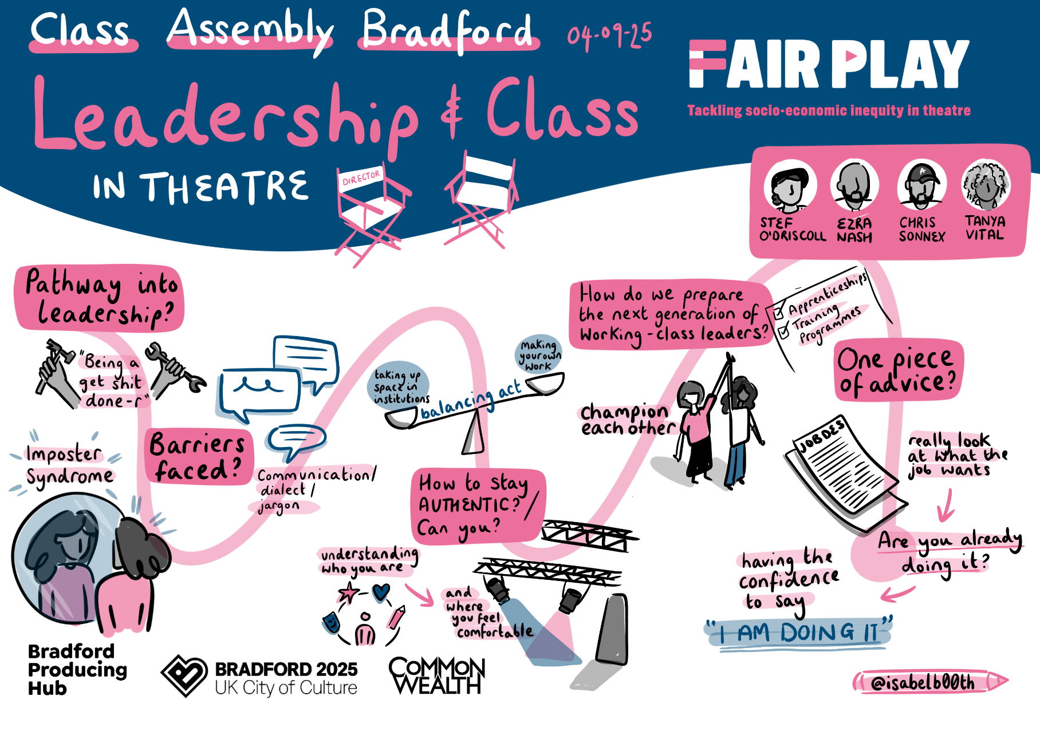

THE TEAM
We are a small team making big things happen.
We all work flexibly part time and, in addition, RTYDS engages freelance support (for example, professional financial advice, PR, or website development) as required.
Sue Emmas has led RTYDS as Artistic Director and CEO since 2007 and is one of the leading figures in artist development in the UK, having also formed and led the Young Vic Creators Program (previously the Directors Program). She is also a freelance consultant working with companies such as The Bush, Rifco Theatre Company and Tara Theatre.
Holly Aston joined RTYDS as Executive Director in March 2026 and brings with her a wealth of knowledge as a senior producer, Theatre Consortium Clore Fellow and RD1st qualified coach. Holly has over 15 years of experience with companies including Factory International, the Young Vic, National Theatre, Donmar Warehouse and RSC.
Critically acclaimed working class directors Stef O’Driscoll and Caitriona Shoobridge are Co-Creative Leads on Fair Play.
Caitriona Shoobridge is an award-winning director and dramaturg working in theatre, audio and film. As a director, she has made work with the Young Vic, Almeida, Lyric Hammersmith, Audible, Walks of life Films and BBC.
Stef O’Driscoll is a critically acclaimed and award-winning theatre director, previously the Interim Artistic Director at The Gate. She has directed plays with criminal justice organisations Clean Break and Synergy, where she is currently an Associate Artist.
Manli Siu, our Programme Producer, has previously worked at the Royal Exchange Theatre in Manchester in the Development team and at Harrogate Theatre as their Administrator. She has a background working in a variety of sectors including the arts, education, and digital marketing.
The three Fair Play Associate Artistic Directors also contribute to our thinking and our projects. Jamie Sophia Fletcher at Leeds Playhouse, Rikki Henry at Bristol Old Vic and Yusra Warsama at Liverpool Everyman & Playhouse.

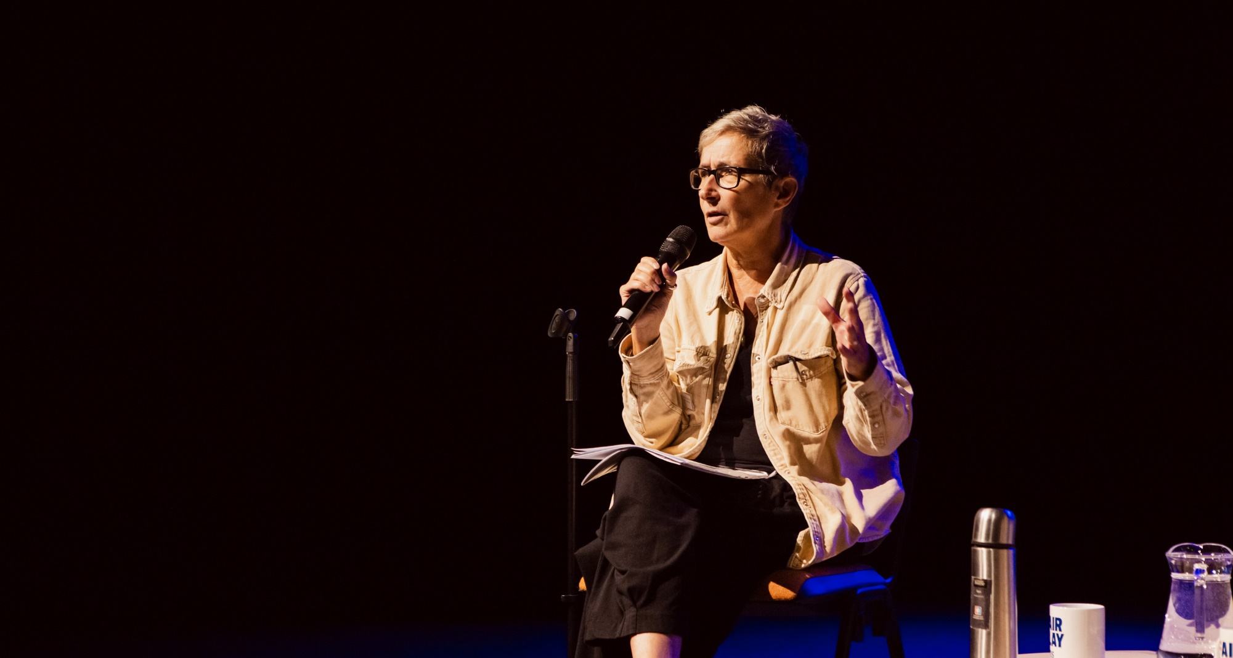
Photo by Tom Woollard

THE BOARD
RTYDS is an independent company limited by guarantee and a registered charity. The Board (nine Trustees) consists of artistic directors and leaders of theatres, freelance theatre artists and Trustees with financial and organisational skills that underpin the company’s resilience and sustainability.
In the 2025/26 Financial Year, the charity had an annual turnover of £509,323. In 2025 we received a two-year project grant from Arts Council England to deliver Fair Play.
The Board meets quarterly and Trustees are responsible for the overall governance and strategic direction of RTYDS. This includes developing the organisation’s aims, objectives and goals in accordance with the governing document, legal and regulatory guidelines. Trustees ensure that RTYDS delivers on our vision, mission and values.
They offer leadership including helping RTYDS to ensure an inclusive working culture. They work closely with the RTYDS Artistic Director and Executive Director on our strategic and operational plans. They are passionate about our work and role challenging class inequity.
Our Trustees are: Atri Banerjee (Director), Christina Clarke (Chair, Founder C21 Creative Communications), Dermot Daly (Director), Doreen Foster (Director, Warwick Arts Centre), Adam Kenwright (Founder and Director, Kindred Partners), Anthony Lau (Director), Laura Mallows (Executive Director, ThickSkin), Alex McGowan (Freelance), and Nathan Powell (Creative Director, Liverpool Everyman and Playhouse).
There is currently a Finance and Fundraising subcommittee, and meetings are also scheduled quarterly.
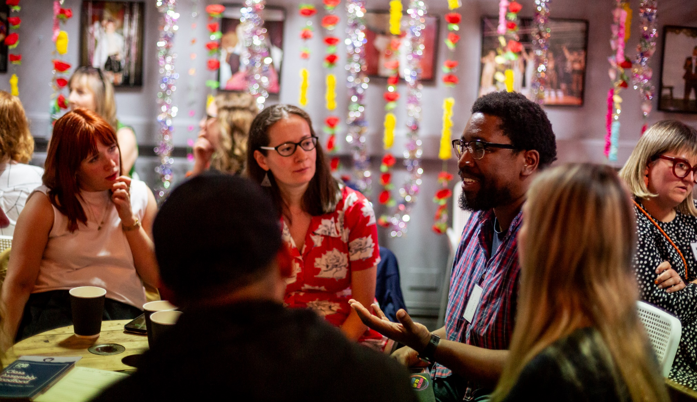
More information can be found on www.rtyds.co.uk
Photo by Tom Woollard

THIS OPPORTUNITY
We are looking for Trustees who are committed to Fair Play’s vision and mission and are committed to support our Chair, Artistic Director, Executive Director and small team, as we move forward to this next chapter for the organisation.
The Board has recently undertaken a skills audit of current and departing members.
We are particularly interested in candidates with any of the following skill set and experience:
- Fundraising – ability to actively support fundraising efforts with a particular focus on individual giving.
- Communications and PR - with a focus on amplification of the organisational narrative and influencing sector, policymakers, and funders.
- Policy and Advocacy - interest and knowledge in contemporary research or initiatives exploring the lived experience of class-based barriers in the creative industries.
- Cultural Funding & Strategic Development – understanding of the current funding landscape, particularly the Arts Council England and DCMS frameworks and priorities.
We are particularly keen to receive applications from people who continue to be under-represented in our workforce and in the wider theatre industry. This includes people who are: Black or Global Majority; Deaf and or disabled, neurodivergent and LGBTQIA+.
Working-class voices lead, shape, and define our work and we want this also to be reflected in the make-up of our Board.
Prior experience of governance is not necessary as we will provide full and appropriate induction and training for all Trustees.

ROLE DESCRIPTION
Responsible to:
- Chair of the Board of Trustees, and also accountable to the Charities Commission and Companies House.
TIME COMMITMENT
Trustees will contribute to the following:
- One Annual General Meeting and four Board meetings a year. Meetings take place either in the afternoon or evening and last up to three hours.
- Read Board papers in advance of each meeting, including artistic, financial, and strategic reports.
- Contribute to and attend one Board away day per year.
- Where required, advise the Executive team according to the specialist knowledge the Trustee brings.
- Act as an ambassador for RTYDS and support fundraising initiatives.

Location
Meetings will take place via Zoom and once a year we will meet in person for an Away Day.

Remuneration
- The Board of Trustees are volunteers and are not financially remunerated, though reasonable expenses to enable attendance at meetings may be claimed. The Chair will discuss and agree expenses with the Trustee, which can include travel or accommodation, as needed.
- We will ensure access provision is in place.
- Trustees can undertake paid work for RTYDS in their professional capacity in appropriate circumstances, subject to declaring an interest at a Board Meeting and Trustee approval.

Term:
- Three years with a maximum of two terms (six years in total).

Trustees have the following statutory responsibilities
Collectively, the Chair and the Trustees contribute the following:
- Ensure that RTYDS complies with its governing document, charity law, company law and any other relevant legislation or regulations.
- Ensure that RTYDS pursues its objects as defined in its governing document.
- Ensure RTYDS uses its resources exclusively in pursuance of its objects: the charity must not spend money on activities which are not included in its own objects, no matter how worthwhile or charitable those activities are.
- Contribute actively to the Board in giving strategic direction to RTYDS, setting overall policy, defining goals and setting targets and evaluating performance against agreed targets.
- Safeguard the good name and values of RTYDS.
- Ensure the effective and efficient administration of RTYDS.
- Monitoring the internal and external risks facing RTYDS and ensuring measures are in place to mitigate risk wherever possible.
- Ensure the financial stability of RTYDS by monitoring the financial performance of the company, approving the annual accounts and taking responsibility for maintaining the financial solvency and stability of RTYDS.
- Protect and manage the property of RTYDS and ensure the proper investment of RTYDS funds.

PERSON SPECIFICATION
If you haven’t been a Trustee before we will provide training in charity finance and governance.
- Commitment to RTYDS aims and willingness to devote time to carry out responsibilities and advocate challenging class inequity.
- Strategic and forward-looking vision in relation to the objects and aims of RTYDS.
- Good, independent judgement, political impartiality and the ability to think creatively in the context of the organisation and external environment.
- Balance tact with a willingness to challenge and constructively criticise.
- Keeping up to date with the RTYDS programme activity by attending events, reading newsletters and being informed about the programme of work.
- Champion the work of the company, helping to raise our profile at all levels by accessing and sharing broad networks to further the interests of RTYDS.

You can learn about the statutory responsibilities of Trustees from the Charity Commission Guide – The Essential Trustee – What You Need to Know.
It is planned that the Trustees will be in post by the end of September, in a position to attend a staff and Board Away Day and the AGM in November. There will be a full programme of support, shadowing, development, and training (if required) during this period. The Trustees undergo a full induction, including meetings with the Artistic and Executive Directors.

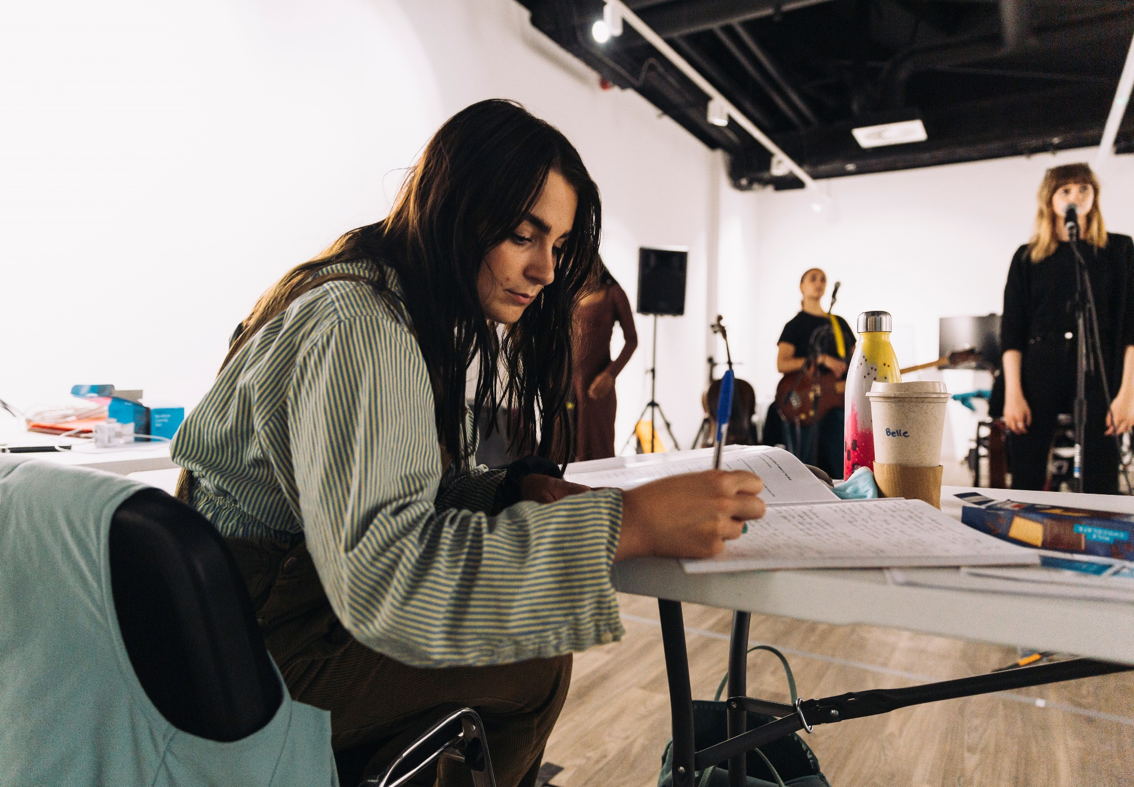
Photo by Anete Sooda

HOW TO APPLY
We are committed to inclusive working practices and ensuring access. We will ask you about any access requirements at each stage of the process. The pack is available in a range of formats, and we welcome written, audio, video BSL applications (please see below for more detail).
The recruitment is led by Christina Clarke (Chair) and a subcommittee of Trustees.
We are very happy to arrange an informal confidential conversation regarding the position before applying. This might be to ask questions about the company, the role, or the process. We are happy to answer all questions.
Please get in touch for an informal and confidential conversation with Christina Clarke by emailing christinaclarke@rtyds.co.uk or Artistic Director Sue Emmas on sueemmas@rtyds.co.uk.
Please let us know your access requirements before the conversation so we can put provision in place.
We would like to hear from you in whatever way feels most appropriate for you. We have outlined some options below, but if you would like to suggest an alternative, please let us know.
- A written letter or statement (approximately one page of A4).
- A video (approximately three minutes spoken or six minutes if in BSL).
- A sound file (approximately three minutes).
In addition, please send:
- A CV
- The name and contact details for two referees - we will not take up references before notifying you.
We are interested to hear:
- What attracts you to RTYDS and Fair Play.
- How your skills, experience and knowledge could contribute to the company.
- How working with us would benefit you and what you would hope to gain.
Audio and video applications should be submitted via WeTransfer, preferably in MP3 or MP4 format.
Please also complete our online Equal Opportunities Monitoring Form. This helps us better understand if our recruitment practices are accessible and equitable to all.
All Deaf or disabled candidates who demonstrate that they meet the essential criteria will be invited for an interview.
If you have any problems with availability on the interview dates (see below), please indicate this in your cover letter.
Deadline for applications: 12 noon, Monday 20 July 2026
Please send your application to Christina Clarke at recruitment@rtyds.co.uk with ‘Confidential: Trustee, RTYDS’ in the email subject line.
All applications will be assessed on content not format.

Interview Process
Interviews will take place in the week commencing 10 August 2026 on Zoom.
If you are invited to interview you will be asked about any access requirements so we can put access provision in place or adjust the interview schedule.

Data Policy
Your information will be held by RTYDS. It will not be shared with any third parties. Find out more about how RTYDS uses your data here: www.rtyds.co.uk/privacy-policy

Appendices
- Equal Opportunities Monitoring Form
- Access Rider

Address: RTYDS, Royal Exchange Theatre, St Anne’s Square, Manchester, M2 7DH
Call us: +44 (0)161 883 0296
Email us: recruitment@rtyds.co.uk
Registered Charity number: 1159966
Follow us on Instagram, LinkedIn and Facebook.

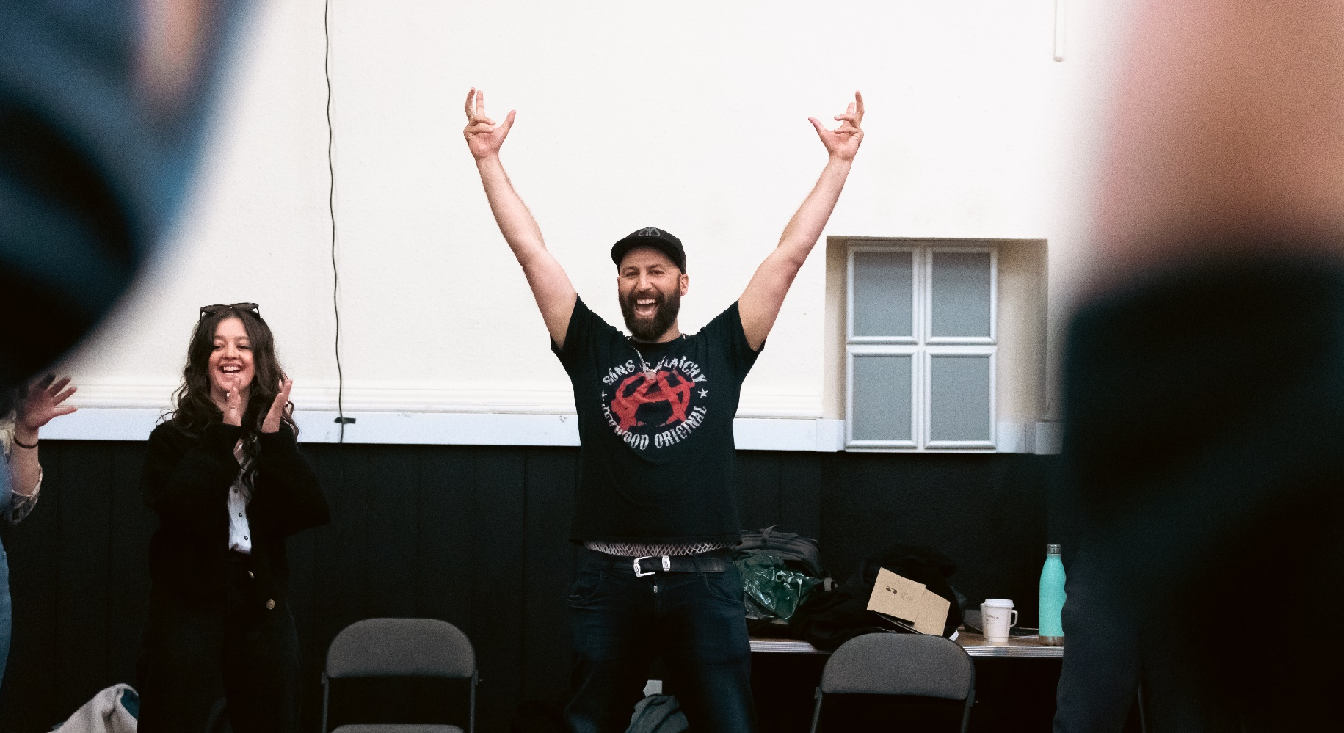
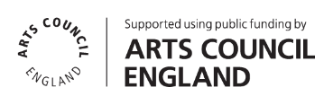
Photo by Emily Appleton

