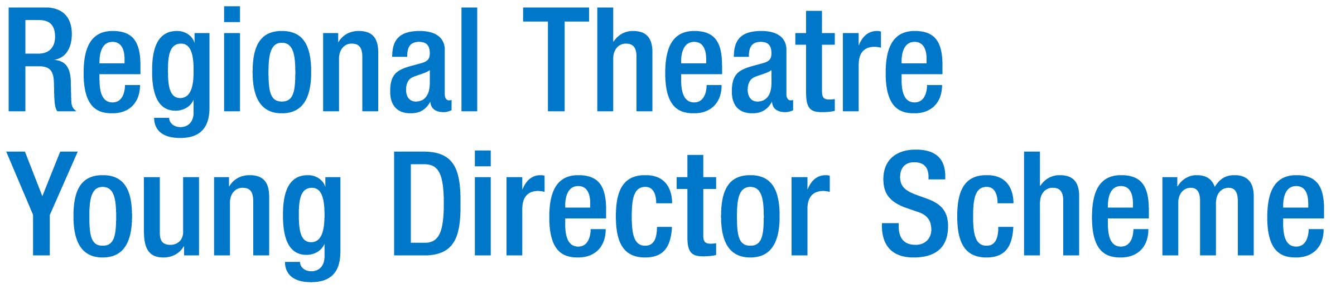

Executive Director Recruitment Pack

Deadline for applications: 12 noon Monday 15th December 2025

Part time three days per week
Salary £28,800 (£48,000 pro rata)
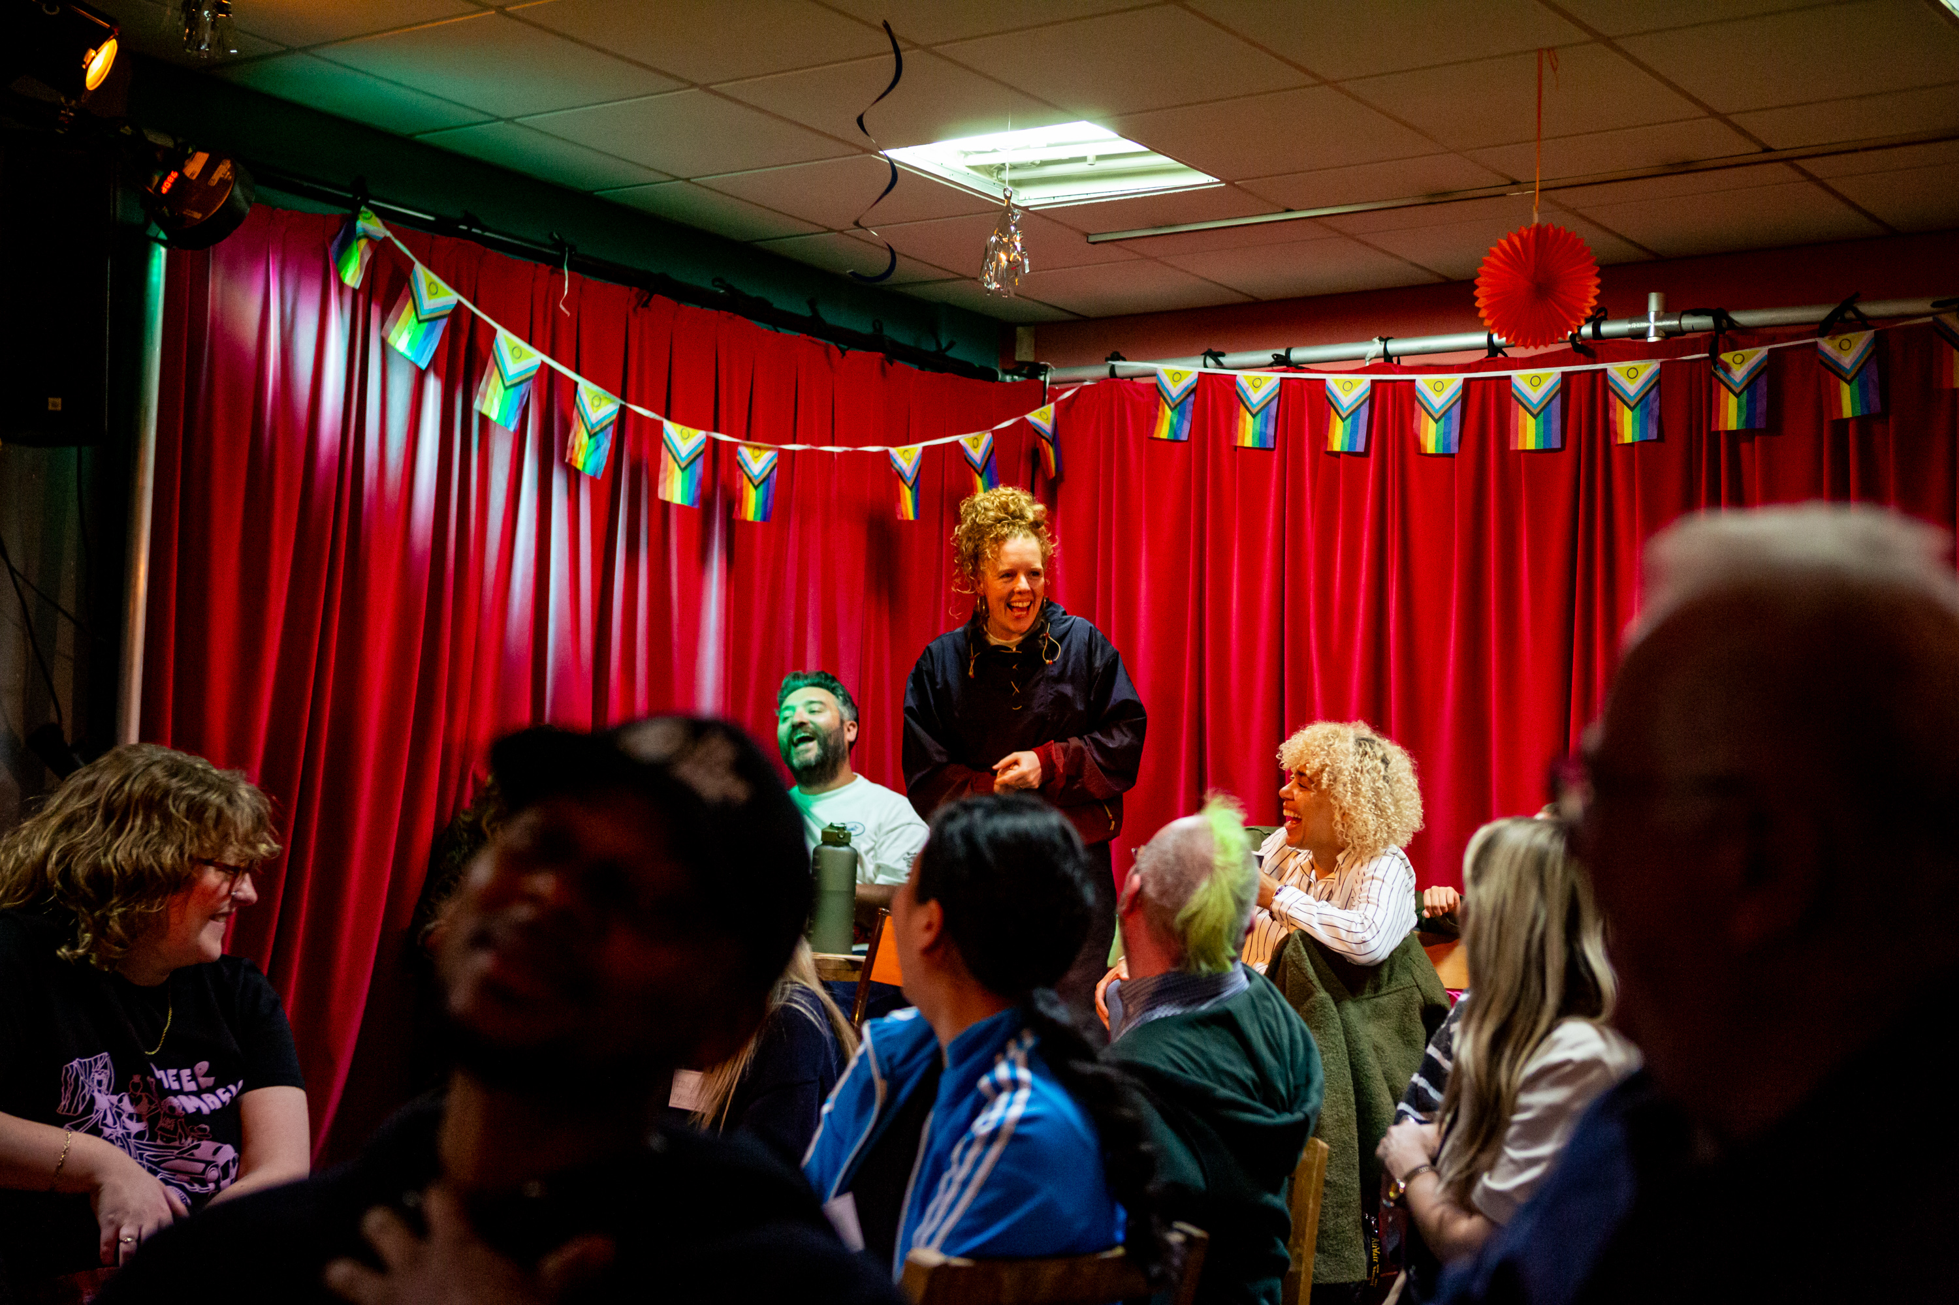
Photo by Tom Woollard
Photo by Tom Woollard
Thank you so much for your interest in the Executive Director role at the Regional Theatre Young Director Scheme (RTYDS). It’s an exciting time for us as we deliver our major new Arts Council Funded project called Fair Play which in partnership with theatres and artists aims to tackle class inequity. We have just recently launched our Associate Artistic Director Residencies with Leeds Playhouse, Bristol Old Vic and Liverpool Everyman & Playhouse and have a range of groundbreaking new initiatives we will kick off in January 2026.

We are looking for a committed and ambitious Executive Director who will join us to deepen our strategy and delivery over the next 18 months. We’re really committed to addressing the barriers experienced by working class and low socio-economic artists to ensure they can sustain careers and thrive in the theatre industry and hope you will help us achieve this.

We hope you find everything you need in the pack about the company, the role but you are also very welcome to get in touch for an informal and confidential conversation with our recruitment consultant, Mary Caws, at cawsmary@gmail.com.

We want you to have the opportunity to tell us about yourself and your interest in RTYDS – Fair Play in whatever way feels most appropriate and we are accepting proposals in writing, video or audio format.

The pack is also available in audio, large print, as a screen reader accessible version, and a format based on the British Dyslexia Association style guide and they can be found at www.rtyds.co.uk/jobs

If you need the pack in an alternative format, please contact recruitment@rtyds.co.uk with your requirements.

We look forward to hearing from you.

CONTENTS

- RTYDS - FAIR PLAY
- THE TEAM
- THE ROLE
- THE SKILLS AND EXPERIENCE WE ARE LOOKING FOR
- TERMS AND CONDITIONS
- HOW TO APPLY

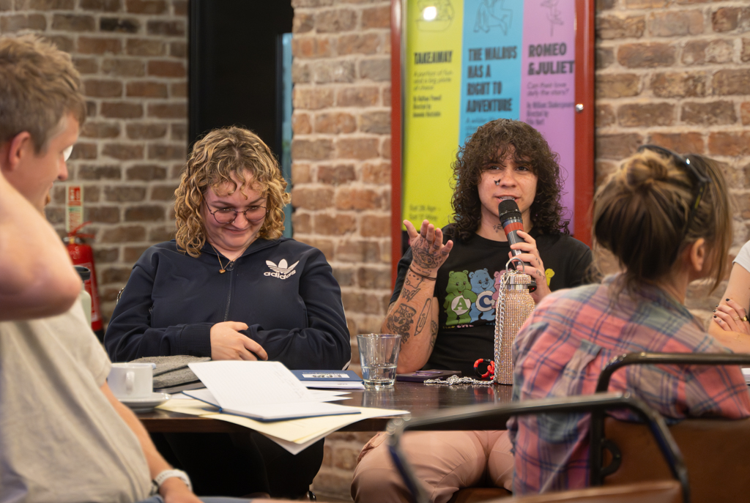
Photo by Brian Roberts

RTYDS - FAIR PLAY

The Regional Theatre Young Director Scheme was started in 1960 by ABC Television to help further the careers of aspiring theatre producers and directors. Its founders believed that television owed a debt of gratitude to the theatre for its supply of creative talent.

Jack Andrews MBE administered the project for 20 years and over this time ensured that it continued to grow from strength to strength. In 2007 he retired and invited the Young Vic to take over his managerial responsibilities for the scheme.

RTYDS was radically reimagined in 2015 with Arts Council England and sector-wide support to challenge and dismantle barriers in artistic leadership arising from inequality of opportunity. We partnered with organisations across England to provide professional development opportunities for new, early career and experienced theatre directors.

RTYDS alumni are leading theatres around the country, with recent appointees including Taio Lawson at The Bush Theatre, Jesse Jones at Royal and Derngate in Northampton, Elizabeth Newman at Sheffield Theatres, Jack McNamara at Live Theatre in Newcastle, Natalie Ibu at Northern Stage in Newcastle, and Corey Campbell at The Belgrade Theatre in Coventry. Directors that have participated in other RTYDS schemes include John Tiffany, Vicky Featherstone and Rebecca Frecknall.

We are proud to have led on change in leadership diversity in theatre, working with theatre partners across the regions for the last 15 years. In 2023 the overwhelming evidence around class-based discrimination compelled us to place all our efforts and tried and tested practices to challenge the systemic barriers that prevent theatre makers from working class or low socio-economic backgrounds from sustaining creative careers and fulfilling their potential as artists and cultural leaders.
The crisis of class representation in the arts is well established – but isn’t being tackled.

Our vision is an industry where socio-economic background doesn’t dictate an artists’ artform, destination or career duration. Where working class leaders can thrive and where our theatre sector is robust, socially just, and able to recognise, develop and nurture working class talent.

Our mission is to bring together theatres, theatre companies, trade unions, and third sector experts alongside mid-career artists across England to identify the cultural and systemic barriers that prevent artists from working class backgrounds from sustaining careers and progressing to leadership.

At the heart of Fair Play is lived experience and a driving force behind the ambitions of the initiative are our two Co-Creative Leads, Caitriona Shoobridge and Stef O’Driscoll, who are working alongside Artistic Director Sue Emmas in designing and delivering the programme.

We are currently working with partner organisations such as 20 Stories High, Bradford City of Culture 2025, Bradford Producing Hub, Cardboard Citizens, Liverpool Everyman and Playhouse, Stephen Joseph Theatre and Turn2us.

Fair Play has three focuses:

ADVOCACY: We champion working class artists and their experiences, and for the industry to come together to support them.

COLLABORATING WITH ORGANISATIONS: We can advise on best practice, recruitment, and workplace culture. We create programmes in collaboration with organisations that target a specific area of class inequity.

SUPPORTING ARTISTS: Raising awareness within the industry to encourage good practice as well as finding ways to provide connection and advice.

In the summer of 2025, we launched our first wave of Fair Play programmes, including:

Associate Artistic Director Residencies: RTYDS is partnering with Bristol Old Vic, Leeds Playhouse and Liverpool Everyman and Playhouse. Each will host a mid-career director who is working class or from a low socio-economic background, in residence for 18 months. The Associate Artistic Director will develop their craft and understanding of creative leadership in a live theatre environment.

Leadership Pathway Bursaries: A pilot programme which aims to address the significant lack of diversity in those who lead organisations. It will provide a progression route for talented people who hope to be artistic or creative directors. Each participant will receive a fee to cover their time and have access to support, training, workshops and mentoring, working alongside RTYDS’s current cohort of theatre professionals from similar backgrounds who are already on a pathway to leadership.

Surviving on a Shoestring: A 12-month finance equity programme in collaboration with a theatre’s finance, producing and executive teams to trial new ways of paying creative freelancers who are in receipt of benefits. Both theatre buildings and companies can take part and join on a rolling basis.

Class Assembly: Events which will bring together theatres, companies and artists to understand the deep-rooted socio-economic inequity in the arts and take away tangible action points to make change. We have led two events so far; one in Liverpool with 20 Stories High and Liverpool Everyman and Playhouse, and one in Bradford in partnership with Bradford 2025 UK City of Culture, Bradford Producing Hub and Common/Wealth.

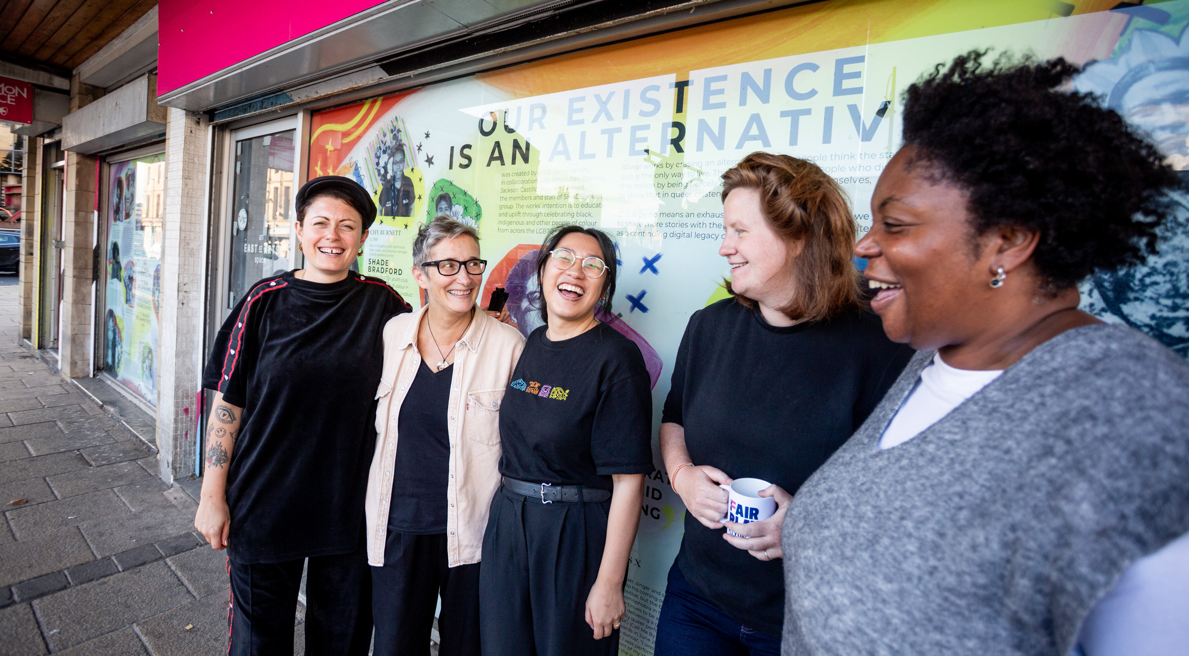

Photo by Tom Woollard

THE TEAM

We are a small team who all work flexibly part time and in addition, RTYDS engages freelance support (for example, professional financial advice, PR, or website development) as required.

Sue Emmas has led RTYDS as Artistic Director and CEO since 2007 and is one of the leading figures in artist development in the UK, having also formed and led the Young Vic Creators Program (previously the Directors Program).

She is joined by critically acclaimed WC/LSE directors Stef O’Driscoll and Caitriona Shoobridge, who have joined RTYDS as Co-Creative Leads to develop and deliver Fair Play. As well as being exceptional artists, Stef and Cat bring their ideas and energy and their invaluable and relevant lived experience in the co-leadership of the project. Manli Siu as Programme Producer brings experience working in theatre, education, and digital marketing.

RTYDS is an independent company limited by guarantee and a registered charity. The Board (12 Trustees) consists of artistic directors and leaders of theatres, freelance theatre artists and Trustees with financial and organisational skills that underpin the company’s resilience and sustainability.

Our Trustees are: Atri Banerjee (Director), Christina Clarke (Chair, Founder C21 Creative Communications), Dermot Daly (Director), Doreen Foster (Director, Warwick Arts Centre), Pam Fraser Solomon (Head of MA Producing, Mountview), Sameena Hussain (Director), Adam Kenwright (Founder and Director, Kindred Partners), Anthony Lau (Director), Laura Mallows (Executive Director, ThickSkin), Alex McGowan (Freelance), Nathan Powell (Creative Director, Liverpool Everyman and Playhouse), Luke Skilbeck (Writer/Director, Artistic Director of Milk Presents).

In 2025 we received a two-year project grant from Arts Council England to deliver Fair Play.

More information can be found on www.rtyds.co.uk

Photo by Tom Woollard
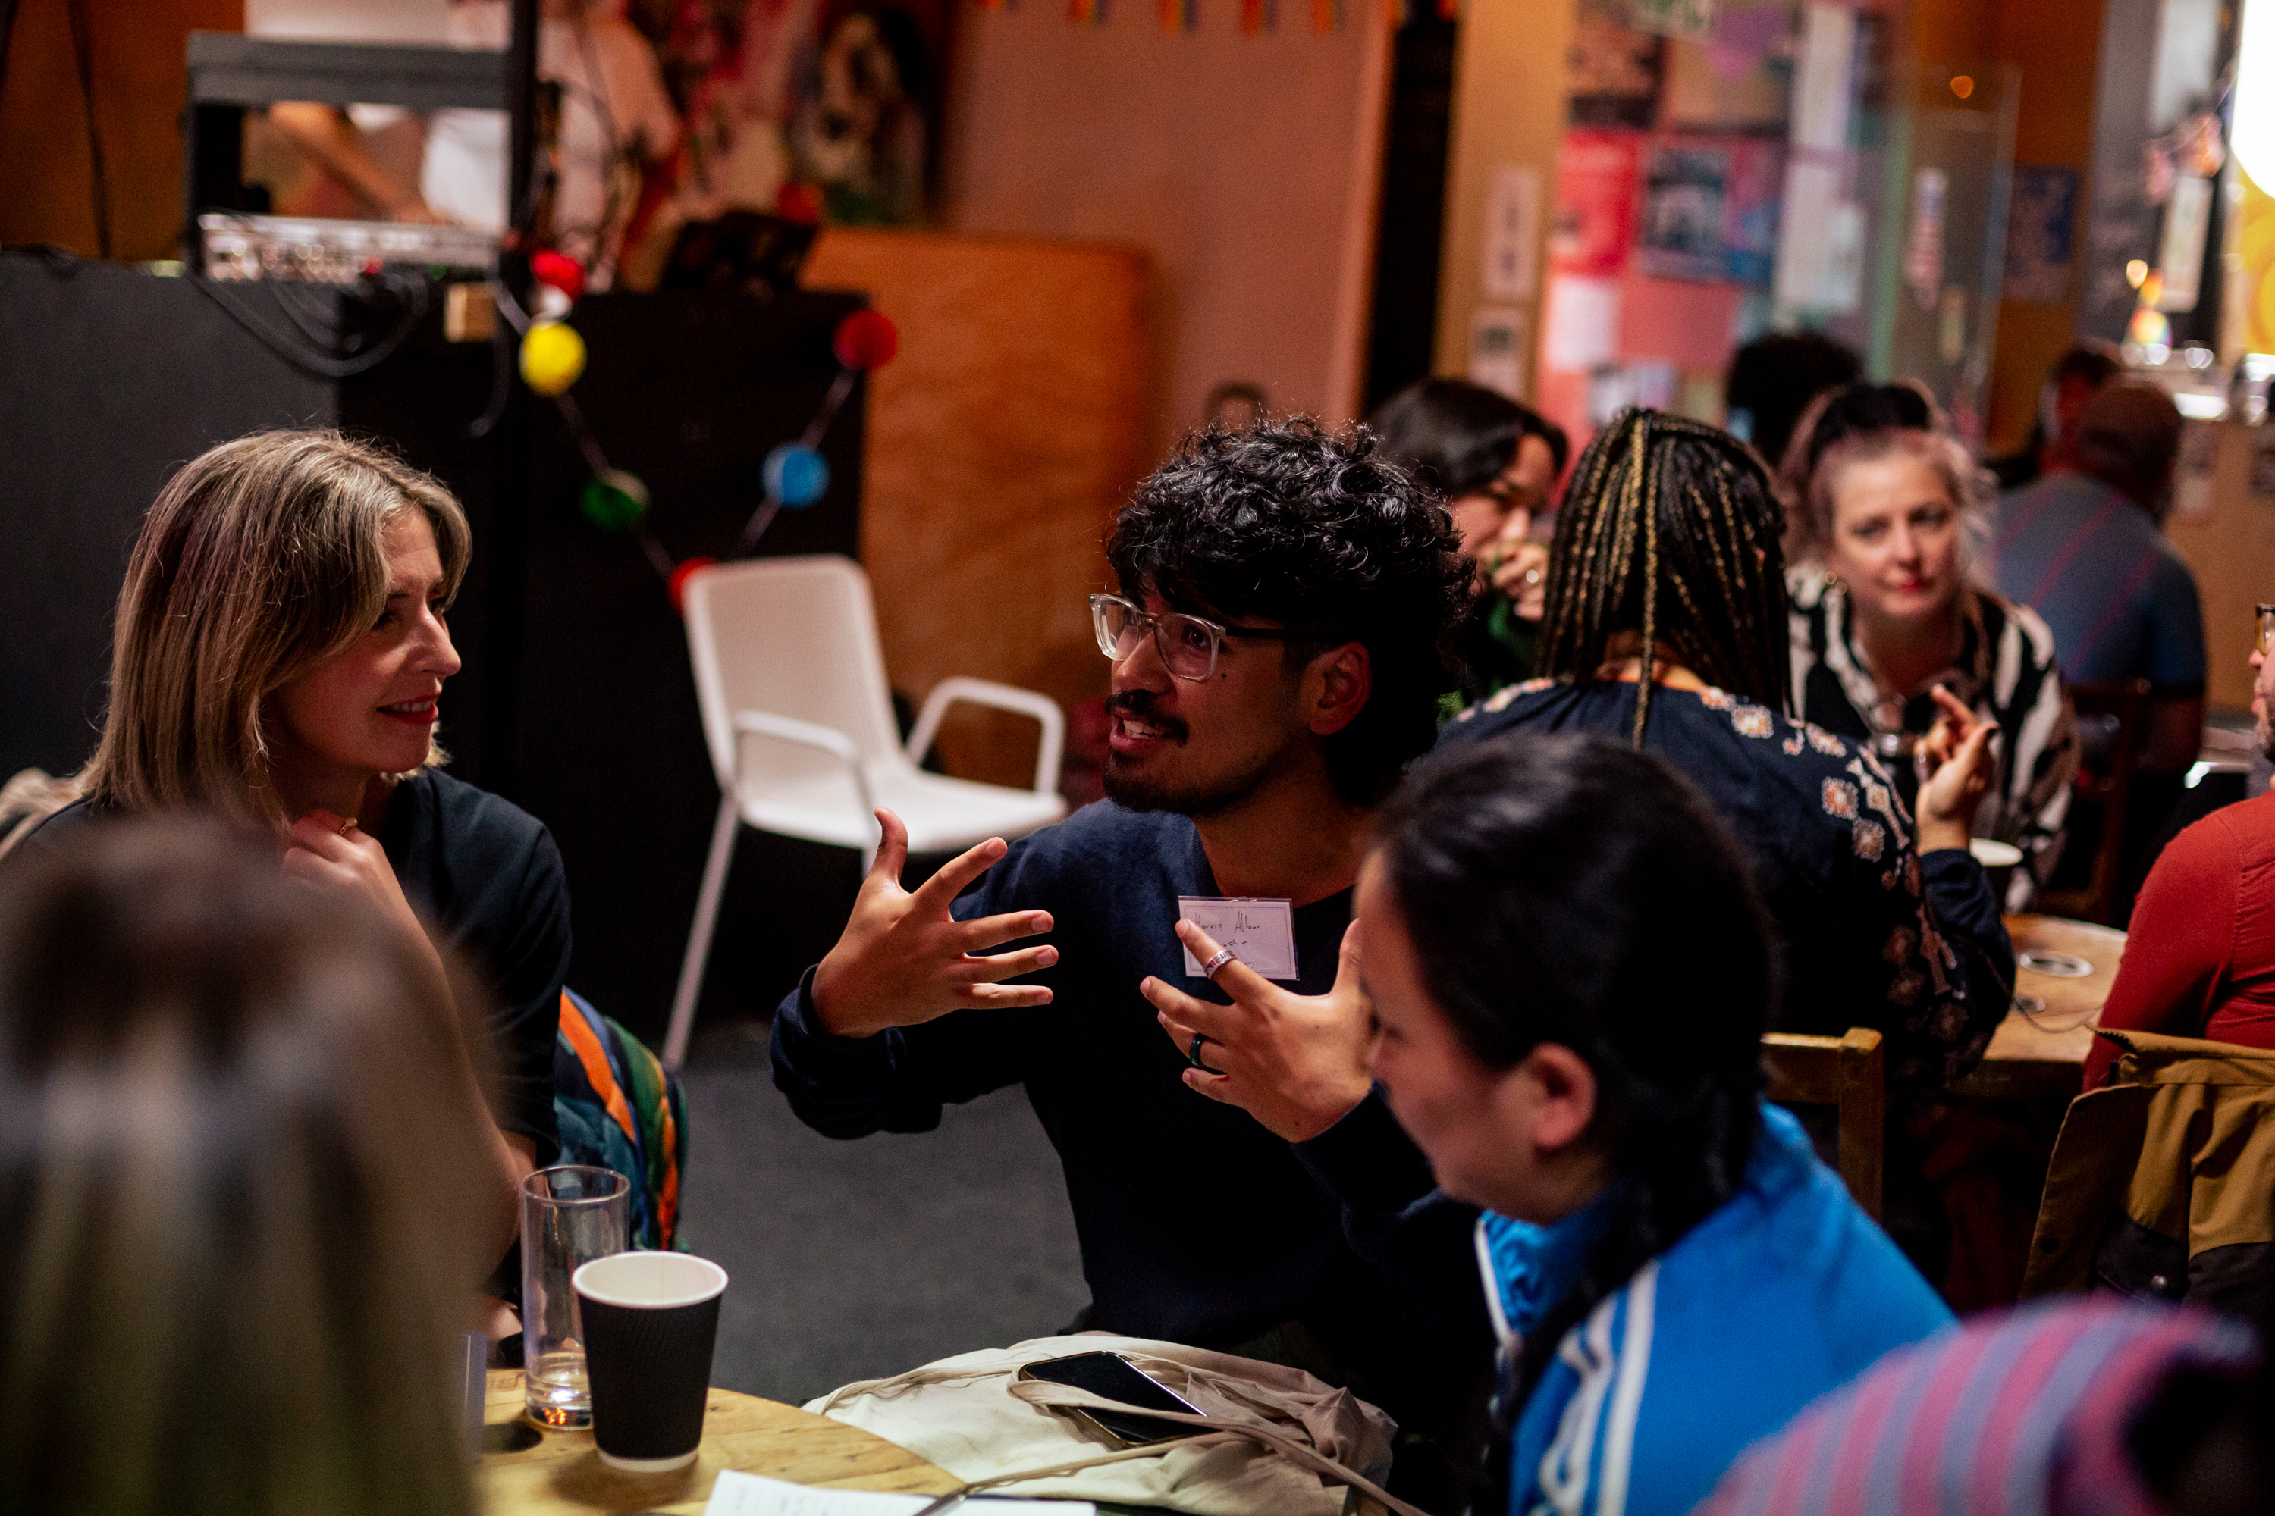
Photo by Tom Woollard

THE ROLE

We are seeking an Executive Director who can help us realise Fair Play and has lived experience of and/or is committed to tackling socio-economic inequity. We specifically welcome applications from candidates who are marginalised and from low socio-economic backgrounds. This includes people who are Black or Global Majority; Deaf and/or disabled, neurodivergent and LGBTQIA+.

We welcome applications from candidates who wish to work in a flexible working pattern (for example around caring responsibilities or access requirements). We are based in Manchester and have an office in London and as a national organisation we welcome applications from locations across the English regions that can easily access either of these two cities for in-person meetings.
The purpose of the role is to lead RTYDS’ fundraising, HR, operations and business planning. As a small company the role is varied and covers many areas. You will have a broad knowledge of the areas listed below but may not have skills and experience in all. We would aim to provide support through our Trustees and training as appropriate.

MAIN RESPONSIBILITIES
- Strategic planning, working in partnership with the Artistic Director/CEO
- Lead on income generation through fundraising and through training and other opportunities.
- Nurture existing relationships with regional theatre companies and organisations such as Equity, ITC etc
- Identify, secure, promote and sustain new partnerships and collaborations that will enhance the future development of Fair Play
- Advocate for the organisation and the project
- Oversee evaluation and monitoring as required
- Keep abreast of legal obligations including Data Protection, Health and Safety and Safeguarding requirements
- Responsible for ensuring risk is well managed, and the risk register is reviewed quarterly at Board meetings

Board
- Act as main contact for the Board and related meetings including quarterly Finance and Fundraising subcommittee meetings
- Attend meetings with Artistic Director and Chair every two weeks for informal catch up and planning
- Draft, collate and issue Board papers for Finance and Fundraising subcommittee and main Board meetings as well as creating minutes
- Responsible for keeping records and filing up to date on Companies House and the Charities Commission

Finance
- With the Artistic Director/CEO, prepare an annual budget for approval by the Board
- Plan, manage and monitor RTYDS finances including overseeing freelance bookkeeper who runs the monthly payroll and raises invoices
- Work with the freelance accountant who produces quarterly management accounts and financial forecasts for the Board, finance subcommittee. Work with freelance accountant to prepare financial information for the annual examined accounts
- Ensure appropriate financial systems are in place to safeguard the company, mitigating financial risk where appropriate
- Ensure the charity is compliant at all times seeking professional advice where necessary

Fundraising
- Develop and lead the income generation strategy in collaboration with the Artistic Director/CEO and freelance experts as needed
- Manage relationships with key funders in collaboration with the Artistic Director/CEO
- Manage relationships with freelance fundraisers
- Contribute to fundraising applications and prepare project related budgets
- Work with Artistic Director/CEO on individual giving strategy and approaches
- Report to Arts Council England as required

HR
- Line management of the Programme Producer, who has a dotted line responsibility to the Artistic Director/CEO
- Approve contracts for freelancers
- Oversee HR and create a positive working environment for staff and freelancers
- Lead on the development of a well-being strategy for staff
- Keep policies updated, including policies that are approved by the Board annually
- Point of contact for freelance staff such as IT, payroll etc.
- Ensure compliance with all relevant employment and safeguarding regulations and demonstrate best practice in implementing Equity, Diversity and Inclusion

Other
- Work across the organisation to support the delivery of the Fair Play programme – ensuring that that all of the programme strands, such as Class Assembly and Fair Play in Organisations are delivered to a high standard
- Undertake any other reasonable duties in order to fulfil the objectives of RTYDS

THE SKILLS AND EXPERIENCE WE ARE LOOKING FOR

Experience
- Demonstrable previous people management experience
- Experience of successful fundraising including public subsidy, trusts, foundations and individual donors
- Track record in relationship building
- Experience of project monitoring, evaluation and report writing
- A broad understanding of contract, employment, and equality legislation
- Understanding of best practice in safeguarding

Skills
- Strong financial management skills including management of budgets
- Proven ability in planning and problem solving
- Fluent IT skills including knowledge of databases, Microsoft Office and e-networks
- Confident written and verbal communication skills
- Ability to manage multiple priorities within agreed timescales
- Strong advocacy, communication and negotiation skills

Attributes
- Demonstrable commitment to equity, diversity and inclusion and specifically socio-economic inequity
- Understanding of barriers to artists’ engagement and development in our sector
- A collaborative and flexible approach when working with others
- Commitment to team wellbeing

TERMS AND CONDITIONS

Please consider applying even if you don’t meet every point of the skills and experience listed. While candidates should fit the majority of the criteria for this role, we would be happy to consider applications from those who are committed to the principles and aims of Fair Play but don’t hit every part of the person specification.

Title: Executive Director
Responsible to: Artistic Director/CEO
Responsible for: Programme Producer and freelance staff
Contract: Fixed term to July 2027 initially, with plans for an extension pending outcome of future funding applications.
Based at: A hybrid format between working remotely and face to face meetings at RTYDS’ base in Royal Exchange Theatre in Manchester. Time in person to be mutually agreed (at least once a month).
Salary: £28,800 (£48,000 pro rata)
Hours: Three days a week but with flexibility to be mutually agreed. Ideally key working days would be Monday and Tuesday (but this is also negotiable) with a floating day to be agreed.
The postholder is expected to work an average of 21 hours per week (with a lunch break). Some travel may be required, which would be covered by RTYDS if it falls outside of commute to RTYDS main office. It is unlikely there will be much evening or weekend work.
Annual leave: 25 days holiday entitlement plus 8 days bank holiday entitlement pro-rata
Benefits: Staff are automatically enrolled in the company pension, operated by NEST. Employees contribute 4% of qualifying earnings. RTYDS contributes 4%.
Probation period: Three months
Notice period: One month by either party during the probationary period and three months thereafter for both parties
Start date: It is anticipated the Executive Director will take up the position as soon as possible depending on their notice period

Any offer of employment will be subject to receipt of:

- References that are satisfactory to the RTYDS Board
- Evidence of a legal right to work in the UK

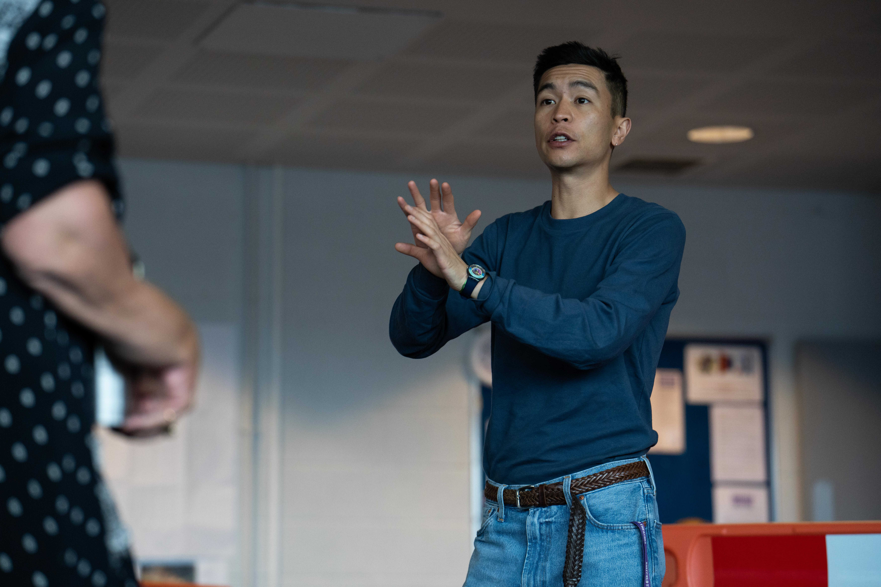
Photo by Sam Taylor

HOW TO APPLY

We are committed to inclusive working practices and ensuring access. We will ask you about any access requirements at each stage of the process. The pack is available in a range of formats, and we welcome written, audio, video BSL applications (please see below for more detail).

The recruitment is led by Sue Emmas (Artistic Director/CEO) and Christina Clarke (Chair) and two other panellists (to be confirmed).

We are very happy to arrange an informal confidential conversation regarding the position before applying. This might be to ask questions about the company, the role, or the process. We are happy to answer all questions. Please get in touch for an informal and confidential conversation with our recruitment consultant, Mary Caws, at cawsmary@gmail.com. Alternatively, you can contact Sue Emmas or Christina Clarke on recruitment@rtyds.co.uk. Please let us know your access requirements before the conversation so we can put provision in place.

To apply please send a CV and covering letter (no longer than two sides of A4), audio or video note (three to five minutes) including:
- What attracts you to RTYDS and Fair Play
- How your skills, experience and attributes match those outlined in the pack
- Name and contact details for two referees who know you in a working environment; where applicable one of which should be your current or most recent employer – we shall not take up references before a second interview and only after notifying you

All applications will be assessed on content not format.

Audio, video and BSL applications should be submitted via WeTransfer, preferably in MP3 or MP4 format.

Please also complete the Equal Opportunities Monitoring Form. This helps us better understand if our recruitment practices are accessible and equitable to all.

All Deaf or disabled candidates who demonstrate that they meet the essential criteria will be invited for an interview.

If you have any problems with availability on the interview dates (see below), please indicate this in your cover letter.

Deadline for applications: 12 noon, Monday 15th December 2025

Applications should be addressed to: Sue Emmas, Artistic Director, RTYDS and sent via email to recruitment@rtyds.co.uk with ‘Executive Director, RTYDS’ in the subject line.

Interview Process
Candidates invited for interview will be contacted by close of Monday 22nd December 2025

The process will include two rounds of panel interviews.
First interviews: Week commencing Monday 12th January 2026
Second interviews: Week commencing Monday 19th January 2026

Interviews will take place on Zoom or in person (likely in Manchester), depending on personal preference. We will provide travel expenses, and the space will be accessible.

If you are invited to interview you will be asked about any access requirements so we can put access provision in place or adjust the interview schedule.

Data Policy
Your information will be held by RTYDS. It will not be shared with any third parties. Find out more about how RTYDS uses your data here: http://www.rtyds.co.uk/privacy-policy/

Appendices

1. Equal Opportunities Monitoring Form
2. Access Rider

RTYDS, Royal Exchange Theatre, St Anne’s Square, Manchester, M2 7DH

Call us: +44 (0)161 883 0296 Email us: rtyds@rtyds.co.uk

Registered Charity number: 1159966

